B.Tech Program First Year

Course: Experiential Learning

Course Code: DA1001

## Phone Book

by

**Shubhankar Ranjan**

**(219302428)**

Under the guidance

of

**Dr. Shally Vats**

**Assistant Professor**

Information Technology, Manipal University Jaipur, Jaipur (Raj.).

**Department of Information Technology**

**School of Computing and Information Technology**

**Faculty of Engineering**

**Manipal University Jaipur, India**

February, 2022

# Table of Content

**Description Page No.**

Certificate 3

Acknowledgement 4

Abstract 5

Introduction 6 – 7

Software and Hardware requirements 8

Literature Review 8 – 10

Methodology 11 – 12

Uses and Drawback 12

Results and Discussion 13 – 21

Conclusion 22

Future Prospects 23

Bibliography 24

# Certificate

This is to certify that the project titled **“Phone Book”** is a record of the bona fide work done by **Shubhankar Ranjan** (Reg No:219302428)submitted for the partial fulfilment of the requirements for the completion of the Experiential Learning (DA1001) course in the Department of Information Technology of Manipal University Jaipur, during the academic session October - March 2022.

|  |
| --- |
| *Signature of the mentor* |
| Dr. Shally Vats  Assistant Professor  Department of Information Technology |
| *Signature of the HoD* |
| Dr. Pankaj Vyas  Head of the Department  Department of Information Technology |

# Acknowledgement

In successfully completing this project, many people have helped me. I would like to thank all those who helped me directly and indirectly to complete my project successfully.

Primarily, I would thank God for being able to complete this project with success. Then I would like to express my deep gratitude towards my mentor Dr. Shally Vats, Assistant Professor, Department of Information Technology. Her support, suggestions and directions have helped in the completion of this project.

Finally, I would like to thank my parents and friends who have helped me with their valuable suggestions and guidance and have been very helpful in various stages of project completion.

# Abstract

Phone Book System is a small application developed for mini project students. In olden days we stored all our important contact details in books and papers. Here we proposed a new system, by using this application we can store all details in this application.

In manual method if we forget information book then it is very difficult to get the contact details and it is also hard to search contacts by turning pages over and over. By using this application, we can see our contacts anywhere. In this project we can save our contacts and we can search them by name and we can also see all of them at a time.

Phone book application is primarily meant for keeping the records of the persons. Phone book application will provide the basic set of features of adding a new contact, searching, updating, deleting a contact. This mini project in C++ Phonebook allows to perform simple Phonebook operations like in the mobile. One can add, list, modify, search and delete Phonebook-related records. File handling and data structure concepts has been extensively used for almost all functions in this mini project. Phonebook in C++ is a console application without graphics. The source code is complete and totally error-free. It is compiled in Visual Studio Code with GCC compiler. Functions, file handling and data structure are used. This application contains how to add, list, modify or edit, search and delete data to/from the file. Adding new records, listing them, modifying them and updating, search for contacts saved, and deleting the phonebook records are the basic functions which make up the main menu of this Phonebook application. Personal information such as name, surname, phone number and address are asked while adding a record into the Phonebook. These records can then be modified, listed, searched for and removed.

# Introduction

Phonebook is a very simple mini project in C++ that can help you understand the basic concepts of functions, file handling and data structure. This application will teach you how to add, list, modify or edit, search and delete data to/from the file.

Adding new records, listing them, modifying them and updating, search for contacts saved, and deleting the phonebook records are the basic functions which make up the main menu of this Phonebook application.

Personal information such as name, surname, phone number and address are asked while adding a record into the Phonebook. These records can then be modified, listed, searched for and removed. It is estimated that there are more than 600 million mobile phone users around the world – and the number is increasing. The success of mobile phones seems easy to explain: being available anytime and anywhere. If a businessman moves from one place to another he is available for his company at no extra effort. If the son will be late at home he can inform his parents. If you have trouble with your car you can call the breakdown service. Mobile phones are used for communication but also for coordination between people. Informal meetings between people (e.g. going to a restaurant) are often not planned anymore in advance – they are arranged on time by mobile communication. Altogether there are a lot of opportunities using mobile phones. But there are also some emerging problems. Being reachable always and everywhere is solved by technology – but being reachable does not necessarily mean being available to all potential callers! Sharing information about the real world context of users is a solution to this problem . But until now the user interfaces of mobile phones are still very much based on legacy. In particular UIs and standard applications are not context dependent and therefore the caller has very little chance to know when making a call in what situation the called party will be interrupted.

The main idea of the program is to increase the awareness of working with computer systems and utilize computer resources for better result orientation. The main target behind the creation of this package is to remove the pressure from the user to learn about computer & software. It helps to maintain an automatic communication between the computer and the user. This Program “Phone Book” facility the user with different records can add and search easily by using Button tools & Search options. There are some features also like: - Viewing Data, and Exit. Our Project has following :- Login form “ADD” button for adding data in Database. “DELETE” button for deleting data in Database. “UPDATE” button for updating data in Database. “SEARCH” button for searching data in Database.

**Software & Hardware Requirements**

**Software Requirements**

* OS X El Capitan (10.11+)
* Windows 7 (with .NET Framework 4.5.2), 8.0, 8.1 and 10, 11 (32-bit and 64-bit)
* Linux (Debian): Ubuntu Desktop 16.04, Debian 9
* Linux (Red Hat): Red Hat Enterprise Linux 7, CentOS 8, Fedora 24

**Hardware Requirements**

* 1.6 GHz or faster processor
* 1 GB of RAM

# Literature review

Literature survey is the most important step in software development process. Before developing the tool it is necessary to determine the time factor, economy and company strength. Once these things are satisfied, then next steps are to determine which operating system and language can be used for developing the tool. Once the programmers start building the tool the programmers need lot of external support. These support can be obtained from senior programmers, from book or from websites. Before building the system the above considerations are taken into account for developing the proposed system.

**Studied Existing Systems and the Drawback we overcome in these system :-**

**Existing System 1.**

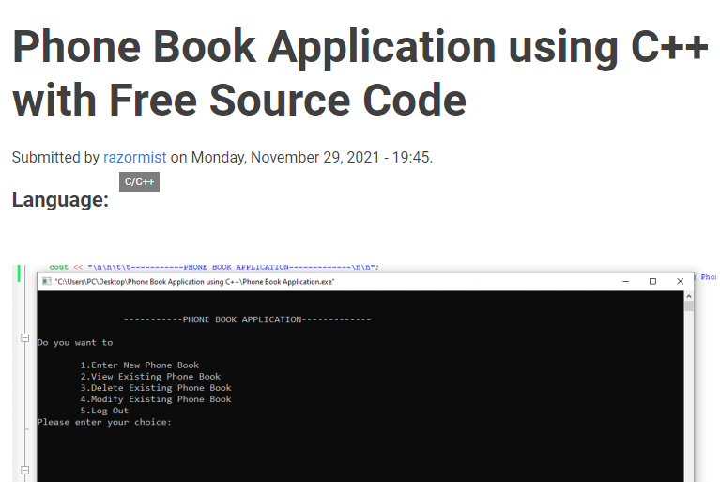

Fig.1

**Drawback overcome in this system:-**

* In this system, there is no option to **search** the existing contact and to **delete all** the existing contacts and to know the **total number of contacts**.
* Hence, we added the option for **search and delete all** the existing contacts and to know the **total number of contacts** in our Phone Book Application.

**Existing System 2.**

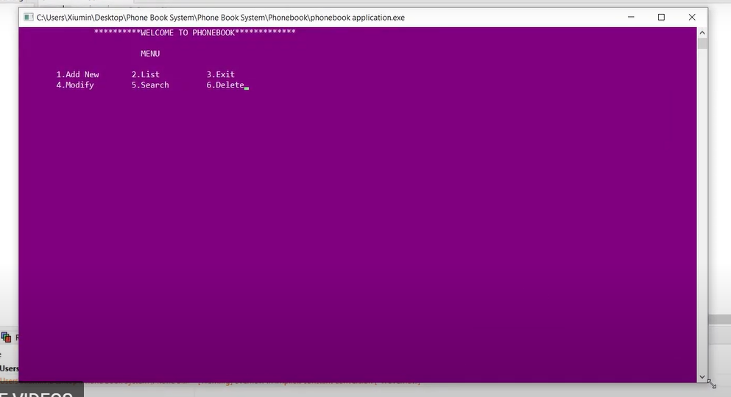

Fig.2

**Drawback overcome in this system:-**

* In this system, there is no option to **search** the existing contact **by number** and to delete all the existing contacts and to know **the total number of contacts**.
* Hence, we added the option for **search by number** and **delete all** the existing contacts and to know the **total number of contacts** in our Phone Book Application.

# Methodology

***Flowchart :-***

Starting Screen

Enter Your Choice

Home Screen

**Search by Name**

**Search by Number**

**Display All Contacts**

**Add Contacts**

**Update Contacts**

**Exit**

**Total Number of Contacts**

**Delete All Contacts**

**Delete Contacts**

Flowchart. 1

**Library used :-**

**Header Files in this project which is used are :-**

* **#include<iostream>**

 iostream provides basic input and output services for C++ programs.

* **#include<windows.h>**

windows.h  is a Windows-specific header file for the [C](https://en.wikipedia.org/wiki/C_(programming_language)) and [C++](https://en.wikipedia.org/wiki/C%2B%2B) programming languages which contains declarations for all of the functions in the [Windows API](https://en.wikipedia.org/wiki/Windows_API), all the common macros used by Windows programmers, and all the data types used by the various functions and subsystems.

**Uses of Phone Book :-**

* Fast Speed Data Processing.
* To record the details of various data of users.
* It will simplify the task and reduce the paper work.
* The system is very user friendly.
* Easily accessed by applicants.

**Drawback :-**

* Applicants record must be available within the file system.

# Results and Discussions

**Starting Screen of Phone Book :-**

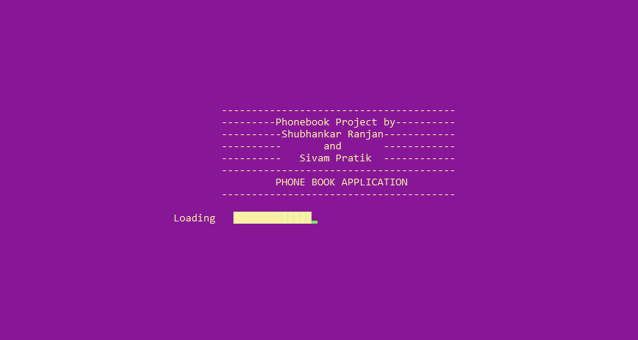

Fig.3

**Home Screen of Phone Book :-**

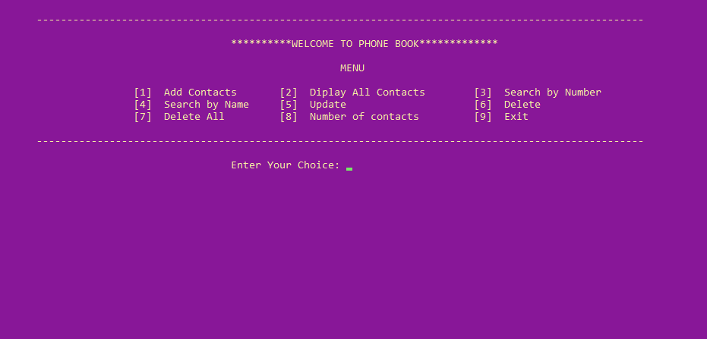

Fig.4

1. **Add Contacts :-**

This feature allows you to add a new contact to the contacts-list of the Phonebook application. Adding new contacts is very easy. You just need to enter the contact’s name, surname, phone number and address.

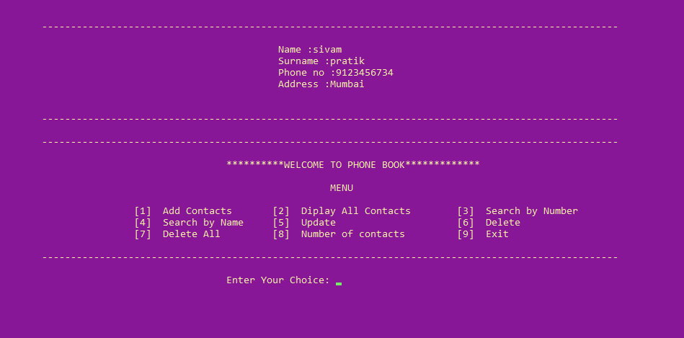

Fig.5

**2.Display All Contacts :-**

You can see the list of the names along with their phone numbers and addresses using this feature. This feature shows you the contact list. All the contacts are shown one by one in a list.

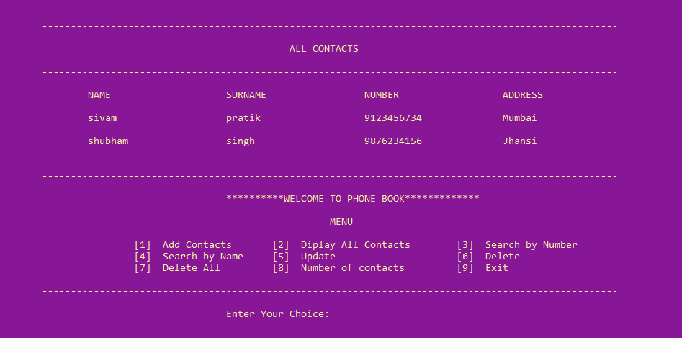

Fig.6

**3.Search by Number :-**

The searching facility lets you search a contact by phone number. You can search a contact by entering the contact’s phone number. If the contact is not found, an appropriate message is shown.

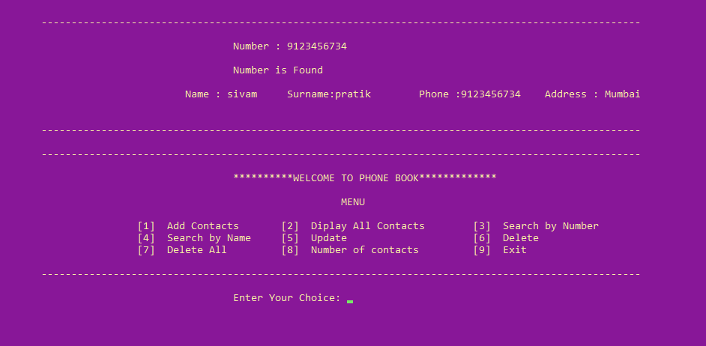

Fig.7

**4.Search by Name :-**

The searching facility lets you search a contact by name. You can search a contact by entering the contact’s name and surname. If the contact is not found, an appropriate message is shown.

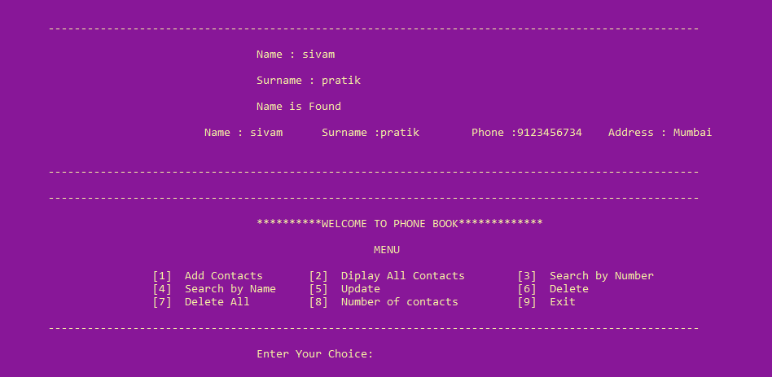

Fig.8

**5.Update Contacts :-**

The existing contacts can be edited using this feature. You can edit the existing contacts and save them to the contacts-list.

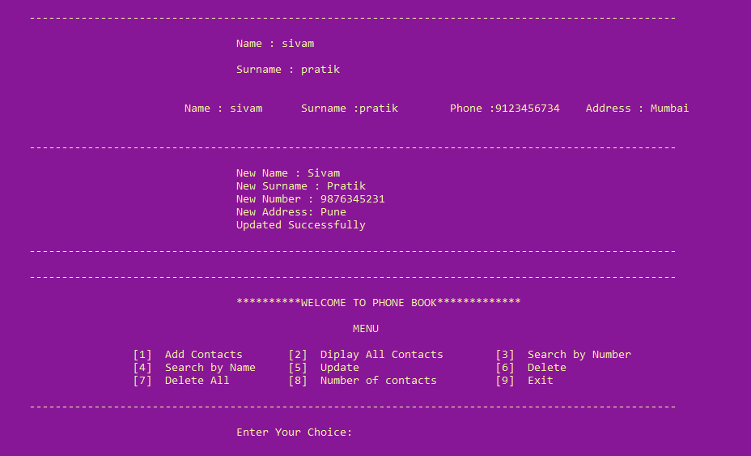

Fig.9

**6.Delete Contacts :-**

Contacts can be deleted from the contacts-list. You can delete a contact from the main menu.

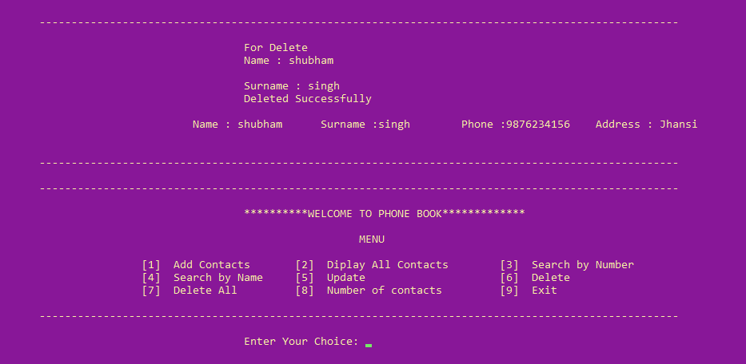

Fig.10

**7.Delete All Contacts :-**

All Contacts can be deleted from the contacts-list. You can delete all contact from the main menu.

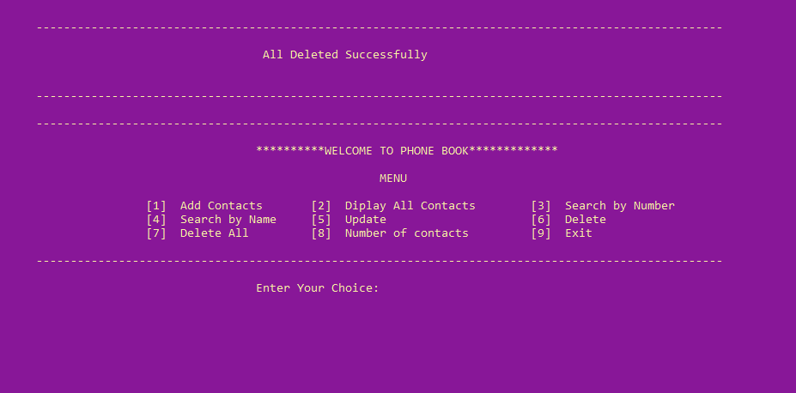

Fig.11

**8.Total Number of Contacts :-**

You can see the total number of contacts using this feature. This feature shows you the total number of contacts saved in the application.

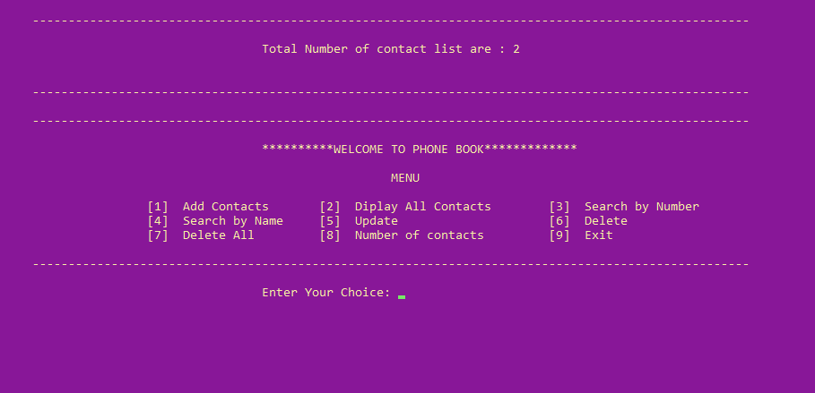

Fig.12

**9.Exit :-**

This option helps us to close the Phone Book Application.

# Conclusion

This study has shown that this application is a feasible method to store any contacts than book and papers. The application software has been implemented successfully by using test cases. And the language used is C++ language. This application is used to search, delete, modify and some functions which is used to remember details of contacts more easily.

# Future prospects

It is not possible to develop a system that makes all the requirements of the user. User requirements keep changing as the system is being used. Some of the future enhancements that can be done to this system are:

* As the technology emerges, it is possible to upgrade the system and can be online.
* GPS can be added.
* Based on the future security issues, security can be improved using emerging technologies.
* Online with Offline Mode.

# Bibliography

* [Wikipedia, Website: https://en.wikipedia.org/wiki/Telephone_directory](Wikipedia,%20Website:%20https://en.wikipedia.org/wiki/Telephone_directory)
* [Yashavant P. Kanetkar](https://www.bing.com/search?q=Yashavant+P.+Kanetkar&filters=ufn%3a%22Yashavant+P.+Kanetkar%22+sid%3a%2286ff53c4-bf20-c857-e6c2-5054d68b4553%22+gsexp%3a%22ece5b5ba-8edf-425a-cc13-094a4c834dd3_bXNvL2Jvb2sud3JpdHRlbl93b3JrLmF1dGhvcnxUcnVl%22&FORM=SNAPST), Let us C++ (2020), 17th Edition, BPB PUBN
* GeeksforGeeks, Website: <https://www.geeksforgeeks.org/c-plus-plus/>
* Code with Harry, Website: https://www.codewithharry.com/videos/cpp-tutorials-in-hindi-1/